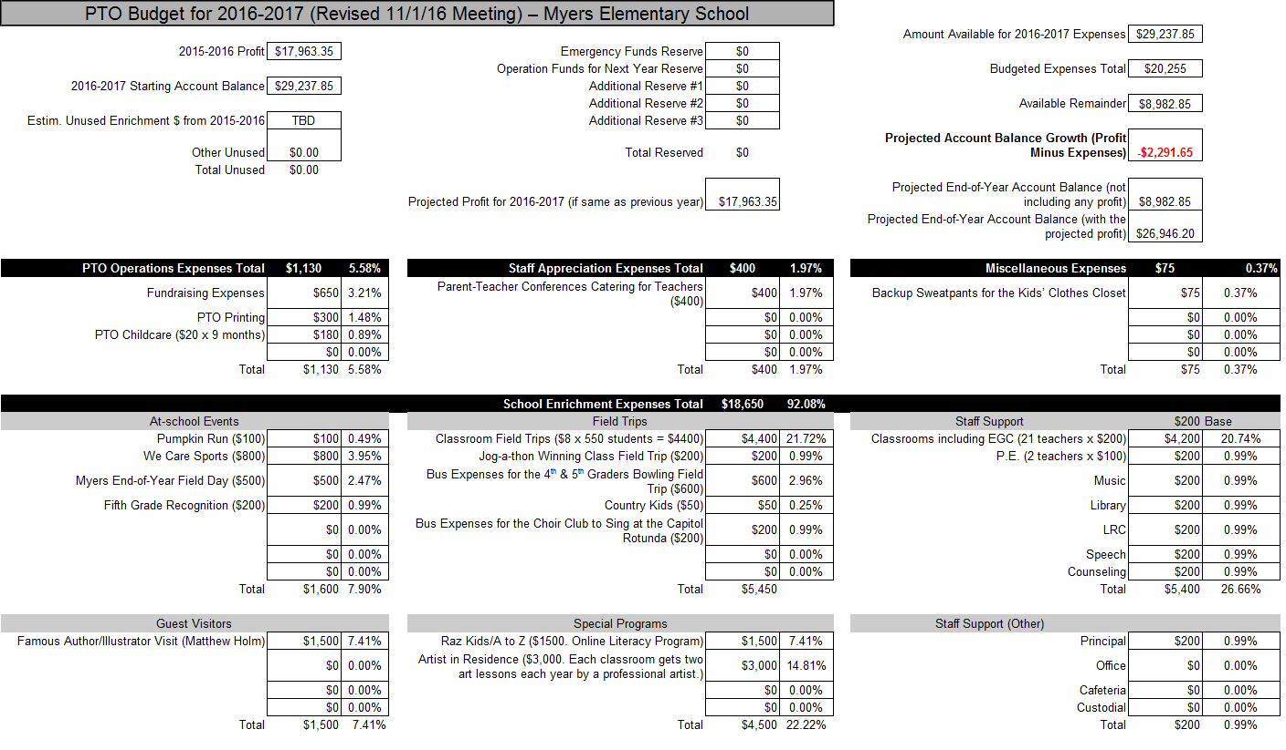

PTO meetings are the first Tuesday of each month at 6:30 PM in the Myers library.
There will be no meeting in December.

